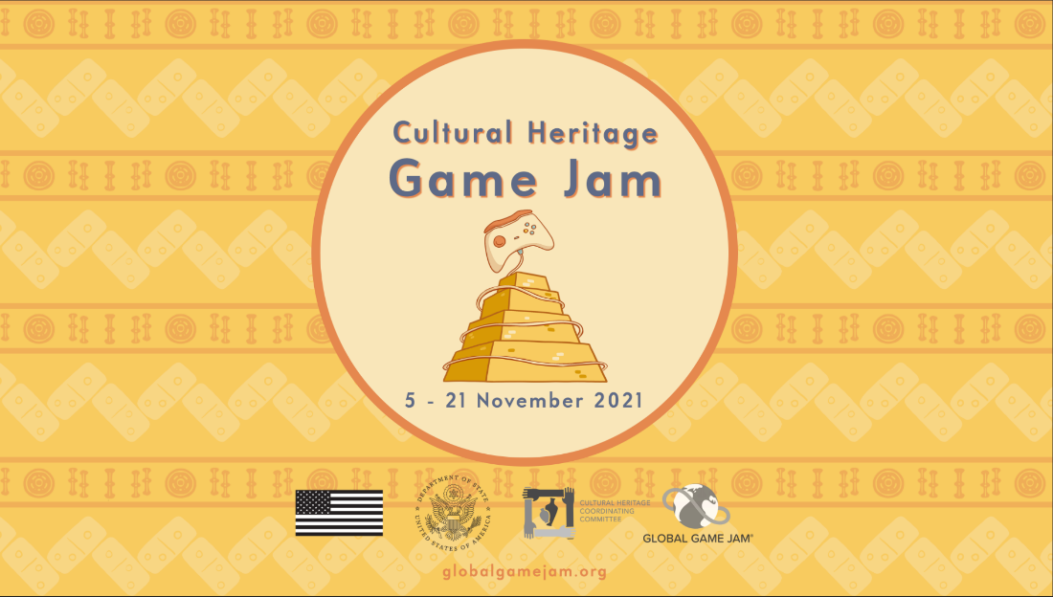
Social Media Toolkit

Background
The Cultural Heritage Center in the Bureau of Educational and Cultural Affairs and Global Game Jam will host a videogame development contest, or game jam, to increase awareness about threats to cultural heritage from theft, looting, trafficking, and destruction. From November 5 to 21, teams of jammers will compete to create videogame prototypes related to the protection of cultural heritage.

All games created will be promoted on the Global Game Jam itch.io page for public play and showcased during a closing ceremony livestreamed from the American Pavilion at the Dubai World Expo in December. The winning jammers will be invited to attend the Game Developers Conference in March 2022, and top games will receive financial support and mentorship for further development.

Posts are encouraged to promote the event by:
- publicizing the game jam on social media platforms
- hosting local teams in American Spaces
- holding “viewing parties” for the opening/closing ceremonies
- connecting with exchange alumni

This toolkit provides guidance on how to encourage your digital audience to engage with the game jam, including hashtags to use, links to design assets, and sample social media content.

If you have any questions about the toolkit or the Cultural Game Jam, please contact Catherine Foster fostercp@state.gov

Hashtags and Handles
#GameDev #CulturalHeritage #IndieDev #ProtectHeritage #GGJ2022

- Facebook: ​@ExchangeProgramsAtState, @StateDept, @USAFCP, @GlobalGameJam
- Twitter: ​ @StateDept, @HeritageAtState, @ECAatState, @ECA_AS, @GlobalGameJam
- Instagram: ​@ExchangeOurWorld, @StateDept, @GlobalGameJam

Important Links
- Press Release from Global Game Jam: https://globalgamejam.org/news/announcing-cultural-heritage-game-jam
- Registration Link: https://docs.google.com/forms/d/e/1FAIpQLSddxlLqWZEb_WYEx_3tZMcdGMvjpLKfiPPNQRymClXq3YSeBw/viewform
- All Graphics (GIF, Banners, Templates): https://usdos.sharepoint.com/:f:/s/ECA_CulturalHeritageCenter/EvJ0_aDeksFGju9wYer8yDwBWE-AXaSzPume8sLtTSN2WA?e=n6pm1F
Events
- Game Jam opens November 5, 2021
- Game Jam ends November 21, 2021
- Closing Ceremony American Pavilion at the Dubai Worlds Expo, December 2021
- Winners attend Global Developers Conference in San Francisco, CA March 2022

Sample Social Media Posts
Game Jam
- Defeat the tomb raider! In partnership with @globalgamejam, @heritageatstate will preserve #culturalheritage and foster the next generation of #gamedevs through the Cultural Heritage Game Jam
Game on November 5-21 ! Register now! 🎮 https://tinyurl.com/v3rtbu87

- Looking to take your #GameDev skills to the next level while protecting #culturalheritage? Register for the @HeritageAtState & @GlobalGameJam Cultural Heritage Game Jam and compete to win mentorship from game industry leaders, and a trip to @Official_GDC! 🎮 https://tinyurl.com/v3rtbu87

- Historic monuments, objects, traditions, and archaeological sites enrich and inform today's societies. Help @heritageatstate and @globalgamejam disrupt looting, trafficking, and destruction of #culturalheritage through the Cultural Heritage Game Jam! #indiegamedevs
🎮 https://tinyurl.com/v3rtbu87

- Are you taking part in the @Heritageatstate & @GlobalGameJam Cultural Heritage Global Game Jam? Post a #selfie and @ your team or share a screenshot of your game! 🤫 Careful not to give too much away to the competition! #gamedev #protectheritage

- DYK #ClimateChange endangers historic sites? Many may be lost forever. Educate others about these dangers and try your hand at #gamedev during the Cultural Heritage Game Jam November 5-21. #protectheritage
🎮 https://tinyurl.com/v3rtbu87

Closing Ceremonies
- Cultural Heritage Game Jam closing ceremony LIVE from @USAExpo2020 at @expo2020dubai! Watch with us and see if your favorite game is a winner
🗓️ December [insert date, once confirmed]
⏰ {insert time, once confirmed]
📱 LINK

Alumni
- Find out how @YlaiNetwork alum Eduardo Ramirez made #gamedev a career, http://ylai.state.gov/designing-a-future-for-himself-why-eduardo-ramirez-is-banking-on-video-games/ and try designing a game to protect #culturalheritage for the Cultural Heritage Global Game Jam. November 5-21

- Find out how @YaliNetwork alum Daniel Okalany created a game business and try your hand at preserving #culturalheritage through #gamedev: Cultural Heritage Game Jam is November 5-21 https://yali.state.gov/entrepreneur-turns-games-into-business/

Drafted: ECA/P/CHC – Nurit Einik 917-443-4738

Cleared:
ECA/P/CHC: Eric Catalfamo (ok)
ECA/P/CHC: Catherine Foster (ok)
ECA/PASC: Elaine Clayton (ok)
ECA/PASC: Russel Solomon (ok)
GPA/DIG/SOC: Ildiko Hrubos (ok)

